

The circuit diagram for 120º mode is shown in Fig. 3.23 (a) which is the same as Fig. 3.20 (a) for 180 º mode. Here, in this type of control, each switch conducts for 120º, with only two switches remaining on in any of the 6 sub-intervals of 60º. The gating signals are shown in Fig. 3.23 (b) from which it can be inferred that the conduction sequence of the switches is 61, 12, 23, 34, 45, 56 in intervals I, II, III, IV, V & VI respectively.

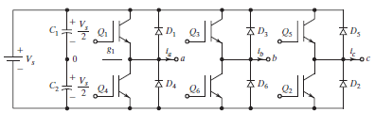

**(a) Circuit**

**Fig. 3.23 Three phase 6 step 120 mode bridge inverter**

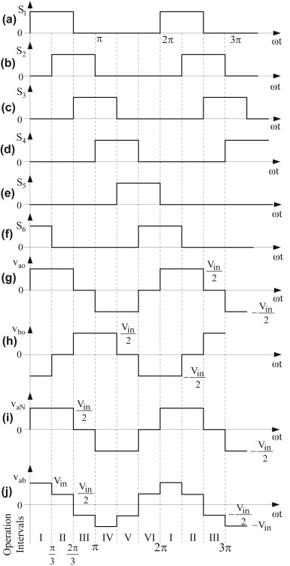

**(b) Waveforms**

**Fig. 3.23 Three phase 6 step 120 mode bridge inverter**

There are six modes of operation in each cycle, with Modes 1, 2 & 3 in the positive half-cycle and Modes 4, 5 & 6 in the negative half-cycle. The equivalent circuits in each of Modes 1, 2 & 3 are shown in Fig. 3.24

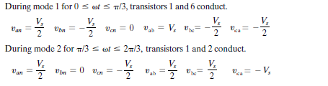

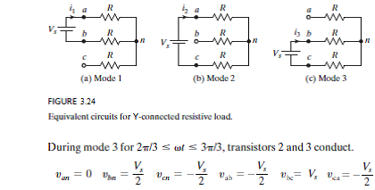

The equivalent circuits for Modes 4, 5 & 6 can be obtained from Modes 1, 2 & 3, respectively, by reversing the polarity of the supply Vs. Accordingly, all phase and line voltages for Modes 4, 5 & 6 will be the negative of the corresponding voltages for Modes 1, 2 & 3.

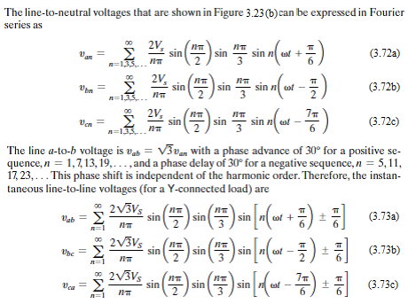



The rms value of the line-to-neutral output voltage can be obtained as:

VP = = = 0.4082Vs (3.74)

The rms value of the fundamental line-to-neutral output voltage can be obtained from Eq. (3.72) as:

VP1 = (3.75)

The rms value of the line-to-line output voltage can be obtained as:

VL =

= = 0.7071Vs (3.76)

The rms value of the fundamental line-to-line output voltage is:

VL1 = = 0.6752 Vs (3.77)

Thus it is seen that for 120º mode, the **line-to-line** output voltage is a **six step** waveform with amplitudes of +/- Vs/2 and +/-Vs, while the **phase** output voltage is a **quasi-square wave** with amplitude of +/- Vs/2 and pulse width of 120º.

This can be compared with 180º mode where it is seen that the **phase** output voltage is a **six step** waveform with amplitudes of +/- Vs/3 and +/-2Vs/3, while the **line-to-line** output voltage is a **quasi-square wave** with amplitude of +/- Vs and pulse width of 120º.